How Does a ROLLOVER CAMPAIGN Work?
UNITED WAY OF SOUTHWEST MINNESOTA

The annual United Way of Southwest Minnesota (UWSWMN) campaign is very dependent on donations from employees who give through a campaign at their workplace. In fact, in our 2021 campaign, combined donations from those companies and their employees made up almost 70% of the $499,000 campaign funds raiser. The remaining 30⁺% came from individuals, small businesses, service organizations, special events and donations from outside of our service area.
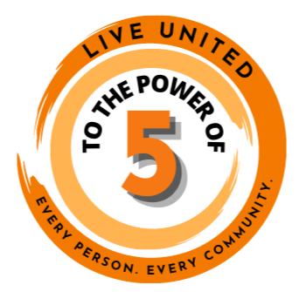
EVERY DONATION MATTERS!

This shows how valuable workplace campaigns are to the success of our mission. We cannot improve lives and strengthen communities throughout our service area without the support of the many companies that allow us to engage their employees!

One option we implemented last year was the option of a rollover campaign. If you think this might be of interest for your workplace, please review the following and reach out to our office with any questions.

What is a rollover campaign?
Rollover giving is an easy way to continue your campaign when your co-workers are not all together in one place. It would allow your payroll deduction donors the option to keep their payroll pledge in place for another year. BEFORE CONSIDERING THIS, YOU MUST verify with your payroll department that this is an option, and find out what verification they would need from each employee.

What are the benefits of a rollover campaign?
1. Your employees can still support UWSWMN and programs throughout our service area even if your workplace isn’t hosting a full, traditional campaign.
2. It is easy for your employees, as their pledge can easily continue. Depending how you set it up, it could continue automatically and they wouldn’t need to take any further action unless they choose to opt out or wish to update the amount of their donation.

What will I need to do to host a rollover campaign?
1. First and foremost, verify with your payroll department what they require from employees who wish to continue/discontinue their payroll deduction pledge.
2. Then reach out to those who are currently giving via payroll deduction outlining the following:
  - Invite them to continue their payroll deduction with the option of increasing the donation amount.
  - Inform them that last year’s payroll pledges will be rolled over for this coming year’s campaign, UNLESS the donor contacts you to opt out by XXXX date.
  - Inform them that their donation will go to the UWSWMN Community Impact fund unless they designate a specific focus area.
3. Also consider reaching out to all employees regarding the options to give in whatever form works for them. They can give via credit card or PayPal via our website donation page at UnitedWaySWMN.org/Donate. We can set up a specific page for your workplace for new payroll deduction pledges. (Contact Julie at julie.decock@unitedwayswmn.org to learn more.)
4. Send updated final listing to your payroll department so they can update their records.
5. Return detail of payroll deduction pledges, along with other funds raised during your internal campaign, to UWSWMN along with the Workplace Report Form.

LIVE UNITED TO THE POWER OF 5!

SAMPLE EMAIL REGARDING ROLLOVER GIVING OPTION:

Dear [donor],

Thank you for your payroll deduction pledge of $[XX] to last year’s United Way of Southwest Minnesota (hereafter UWSWMN). It is currently at work helping improve the lives of local people throughout their service area. If you would like to view the current list of UWSWMN partner programs, go to UnitedWaySWMN.org/CI.

This year, in place of our traditional workplace campaign activities, [Company Name] will allow you to continue your payroll deduction pledge for an additional year. If you would like to take advantage of this option, you do not need to take further action. All donations will continue as set up last year, unless you note changes by contacting [name/email} before [date].

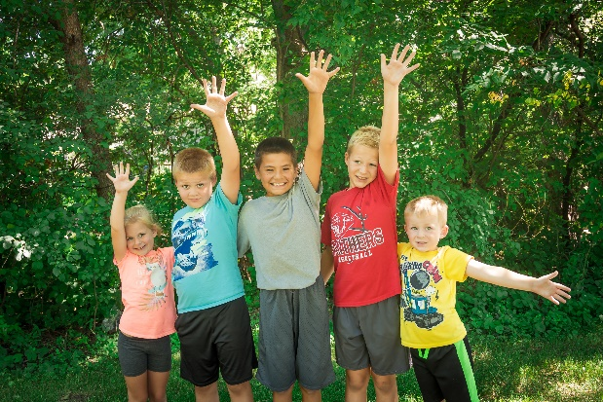
Please consider increasing the amount of your donation in order to increase the impact your donation is having in the lives of local people. If you would like to change the amount of your payroll deduction pledge, please fill out the attached form and return it to [email address] by [date]. New and continuing donations for the new campaign year will start being deducted from your paycheck starting [date].

Thank you for joining your co-workers in giving back to the local communities. Your support is making a difference in the lives of local people!

Sincerely,

[Campaign Ambassador]

