Raise Your Hand
Email Templates

- Last Day to Pledge email:

Body: Time is running out!

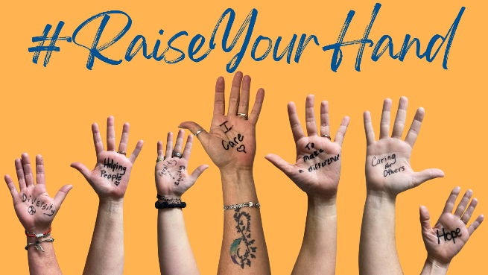

Our United Way Workplace Giving Campaign ends on [Date]!

Here are our results so far…

Dollars Pledged: $____
% of Employees Participating: ______
Remaining to Reach Goal: $_____

If you have been waiting to make your pledge when it counts the most … that time is right now! There is just one day left to make your pledge. We set a goal to support this community and we know with your help we can make that happen.

Please consider donating today. Because change doesn’t happen alone, with your help there’s HOPE - to live better, we must LIVE UNITED.

Thank you for being a Hand Raiser and supporting our community through the United Way of Southwest Minnesota. We appreciate your contribution.

Best,

[name/contact info]

